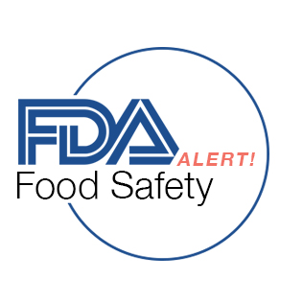

**Usability Test Findings – Summary for Design**

**Findings:**

Positives

* Users liked knowing the tool was powered by FDA data
* Users were able to search easily
* Users liked the level of detail, it included everything they needed to know
* Users liked the ability to sign up to receive alerts, however were hesitant without knowing the volume of recalls currently. Several users said Social Media outlets are their preferred method to receive recall information.

Usability Issues

* Users were most interested in recalls that impacted their state regionally, not for a full list of recalls for the entire state
* Recommendation: Continue to look for ways to track distribution beyond by state.
* Users were likely to search by state or by product/keyword and mentioned wanting to search by both fields at once.
* Recommendation: Revise the design so both search options can be used in unison.
* Users were interested in seeing a picture of the product to help them identify at a glance if they had the recalled item.
* Recommendation: Consider including an image of the item along with the description on the detail view.
* Users indicated they would use the site if they were familiar with it, or if it returned via Google search. They would be more likely to choose this if it returns higher in the results list.
* Recommendation: Consider SEO.

Future Enhancements

* Users were interested in contacting the manufacturers or retailers directly from this site, at a minimum listing the contact information so they did not need to generate a separate search to find the information.